How you protect yourself and your family

Barnsley council continue to monitor the situation across the borough, working closely with partners and Public Health England, adapting their approach as required.

They know that some of the positive cases in the borough are from people socialising together. While people have missed spending time with friends and family, it’s important to remember these two rules:
- When you're outside, don't meet with more than six people together at a time.
- You can only socialise indoors with people from up to two households.
Remember, in both of these situations, you still must social distance and wash your hands regularly. You should avoid touching anything unnecessarily, but anything you do touch should be cleaned. This includes walls, doors, door handles, the toilet, the sink and taps.
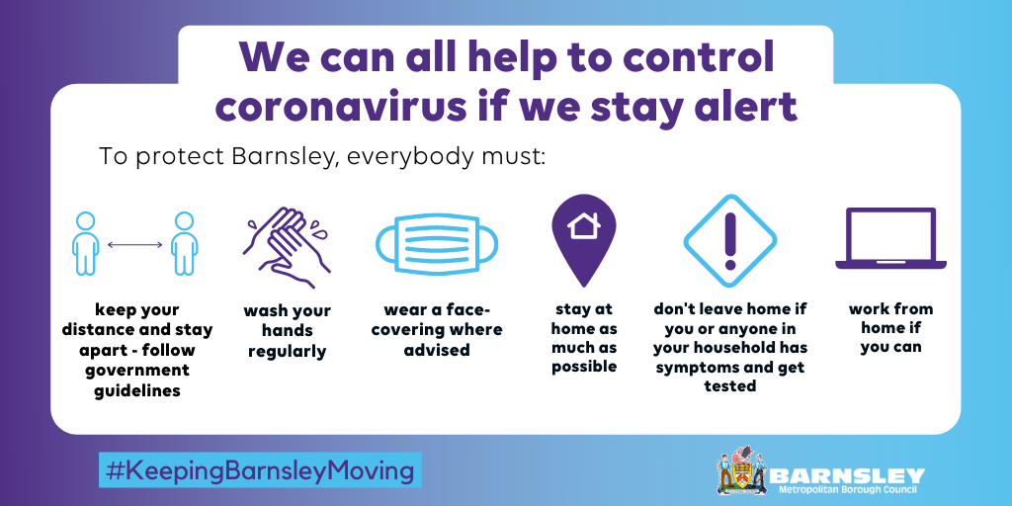

Symptoms of Coronavirus (COVID-19)

The most common symptoms of coronavirus (COVID-19) are recent onset of:

- new continuous cough and/or

- high temperature

- a loss of, or change in, normal sense of taste or smell (anosmia).

Getting a test for Coronavirus (COVID-19)

If you’re concerned in any way, or you have even mild symptoms of Coronavirus (COVID-19), you can get a free swab test that takes less than a minute.

In Barnsley, we have a local testing site on the Courthouse car park in the town centre. We also have a mobile testing unit that will move around the borough.

The Mobile Testing Unit will be in Wombwell on Station Road car park (behind the library), from Friday 21 to Tuesday 25 August and at Mapplewell and Staincross Village Hall, Darton Lane, Mapplewell from Wednesday 26 to Sunday 30 August.

Book your test at www.nhs.uk/coronavirus or by calling 119, and you can expect your result the next day.

When should you self-isolate?

Self-isolate immediately for at least 10 days if:

- you have any symptoms of coronavirus (a high temperature, a new, continuous cough or a loss or change to your sense of smell or taste)
- you've tested positive for coronavirus – this means you have coronavirus.

Self-isolate immediately for at least 14 days if:

- someone you live with has symptoms or tested positive
- someone in your support bubble has symptoms or tested positive
- you've been told by NHS Test and Trace that you've been in contact with someone who has coronavirus.

The 14-day period starts from the day when the first person in the house became ill.

How to self-isolate – reduce the spread of the virus and don’t be a contact
You must not leave your home if you're self-isolating.
Don't
- do not go to work, school or public places – work from home if you can
- do not go on public transport or use taxis
- do not go out to get food and medicine – order it online or by phone, or ask someone to bring it to your home
- do not have visitors in your home, including friends and family – except for people providing essential care
- do not go out to exercise – exercise at home or in your garden, if you have one

For more information visit www.nhs.uk/coronavirus

